PTEN (R159S)
Catalog Number: CR-M26313
Gene Symbol: PTEN, 10q23del, BZS, DEC, GLM2, MHAM, MMAC1, PTEN1, TEP1, MMAC1, PTEN1, TEP1
Description: Anti-PTEN (R159S) Mouse Monoclonal Antibody

Background: Phosphatase and tensin homolog (PTEN) was identified as a tumor suppressor that is mutated in a large number of cancers at high frequency. It is one of the most commonly lost tumor suppressors in human cancer. During tumor development, mutations and deletions of PTEN occur that inactivate its enzymatic activity leading to increased cell proliferation and reduced cell death. Frequent genetic inactivation of PTEN occurs in glioblastoma, endometrial cancer, and prostate cancer; and reduced expression is found in many other tumor types such as lung and breast cancer.
Immunogen: A synthetic peptide from the internal region of PTEN which includes the mutation of R159S, human origin.
Tested applications: ELISA, WB
Recommended dilutions:
ELISA: 1:1000-1:5000
WB: 1:500-1:1000
Concentration: 1 mg/ml
Host: Mouse
Clonality: Monoclonal
Purity: Purified from ascites
Format: Liquid
Storage buffer:
Preservative: no
Constituents: PBS (without Mg²⁺ and Ca²⁺), pH 7.4, 150 mM NaCl, 50% glycerol
Species Reactivity: Recognizes R159S mutant, but not wild-type PTEN from vertebrates.
Storage Conditions: Store at -20°C. Avoid freeze / thaw cycles
Western blot:
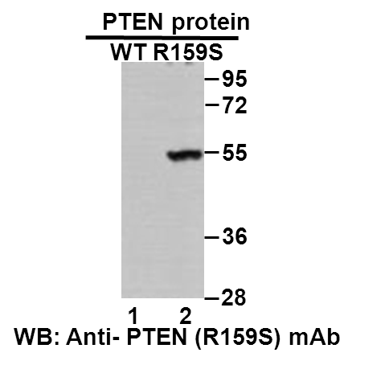
Western blot analysis of recombinant PTEN (R159S) and wildtype proteins. Purified His-tagged FGFR1 (R159S) protein (lane 2) and corresponding wildtype protein (lane 1) were blotted with anti-PTEN (R159S) monoclonal antibody (Cat. #26313).

科博瑞（武汉）生物科技有限公司
TEL：027-87615885 15972062685
- mail：3636901710@qq.com
Web:www.coburybio.com

